Week 6

This week I embarked on the long and frustrating task of completely disassembling the wires from the breadboards and soldering everything onto smaller pieces of soldering board. The reason this took so long was because I had to be constantly checking to make sure that everything still worked. One incomplete circuit can completely destroy the functionality of this device. An especially annoying piece to solder was the MCP3008 chip, because it required lots of precision to keep each leg of the chip separate. Here is a picture of the finished pile of wires, knobs, and chips:

I have been learning the basics of 3d printing which I will need to create the box to house all of the electrical components. I have been using SketchUp for 3d designs and Flashprint for slicing. It is super convenient to be able to tweak things with such precision without starting over. The sculptural building and design I have done in the past has not had that luxury. If I screwed something up, I would need to find a way to work around it or start over. With a 3d printer, I simply make adjust the 3d design and send off another print.

Once I can get a fully functional design, I want to start thinking about the style of this device. It still needs a name by the way! I am thinking about giving it an animal name. That could be funny, and also it would sort of explain the devices role as a musician’s assistant. I want the name to be written on the top of the box in vibrant colors. Here are two examples of a pedals that have funny but sleek designs.

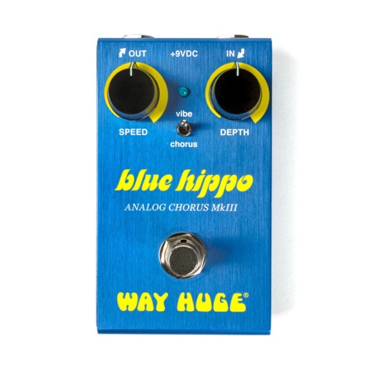

I also am going to for sure need to put “Bergquist-Mauceri Electronics” at the bottom of the pedal, because the people gottttaaa know!